An Interactive Fitness Center

**[Business Plan]**

|  |  |  |
| --- | --- | --- |
| **Chris Sigouin** | **Chelsea Ferguson** | **Mike Gergely** |

**Table of Contents**

1. **[Executive Summary](#ExecutiveSummary)**……………………………………………………………….…5
2. [**Description of Level Up! Gym**](#CompanyDescription)………………………………………………………7
   1. Company Description
   2. Mission Statement
3. [**Management** **Plan**](#ManagementPlan)……………………………………………………………………9
   1. Management Team
      1. Christopher Sigouin
      2. Chelsea Ferguson
      3. Mike Gergely
      4. Gaylene Nicholson
   2. Management Team Gaps
   3. Personnel Plan
4. [**Marketing Plan**](#MarketingPlan)……………………………………………………………...............13
   1. The 4 P’s of Marketing
   2. SWOT Analysis
   3. Industry Analysis
      1. Market Size
      2. Main Competitors
      3. Market Segments
   4. Competitive Edge
   5. Marketing Strategy and Positioning
      1. Pricing Strategy
      2. Promotion and Advertising Strategy
   6. Strategy Pyramid
   7. Website View
   8. Sales Strategy
   9. Legal
   10. Milestones
   11. Exist Strategy
5. [**Operational Plan**](#OperationalPlan)……………………………………………………………………32
   1. Stage of Development
      1. Current Operational Development Status
         1. Development Requirements
      2. Risk in Development Requirements
      3. Industry Association Membership
      4. Suppliers
      5. Quality Control
   2. Production Process
      1. Day-To-Day Operations
         1. General Rules and Regulations
         2. Facility Hours, Duties and Operations
      2. Physical Locations
      3. Equipment
      4. Assets
      5. Inventory
      6. Feasibility
      7. Costs
6. [**Produces and Services**](#ProductsAndServices)…………..………………………………………………….54
   1. Products
      1. Shop
      2. Power Bar
   2. Services

1. **[Financial Plan](#Financials)**……………………………………………………………………….58
   1. Start-Up Expenses
   2. Start-Up Assets
   3. Source and Use of Funds
   4. Break-Even Analysis
   5. Profit and Loss
   6. Balance Information
   7. Budget Sheet

1. **[Appendices](#Appendices)**………………………………………………………………………..…65
   1. Floor Plan
   2. Product Visuals
   3. Social Action Research Project
   4. Key Personnel - Resumes

**Executive Summary**

Fitness requires a hook sometimes to continually pull someone towards a healthier lifestyle. Some find this to be true as they can attest to an improvement in their lifestyle. Others develop it through long struggling periods of time and then may not even continue to pursue it afterwards. This could be caused by loss of ambition, motivation, etc. Today we present to you Level Up! Gym. A revolutionary way to link the fitness world with the ever growing universe of video gaming. With our chosen location at 300 Brackley Point Road, in Charlottetown PEI, we will present the first commercial exergaming experience to the local community.

Level Up! Gym is a partnership equally owned and operated by 4 bright young individuals who have dedicated more than 5 years of their lives into the companies development. Ms. Chelsea Ferguson is our CEO, leading founder and creative mind behind Level Up! Gym. Her background involves a great deal video game engagement and design, graphic design and a solid foundation of software development. Mr. Michael Gergely is Chief Financial Officer (CFO) overseeing all financial aspects of the company. His passion with mathematics and commitment to balance make him the perfect member of our team for this position. He also carriers past experience with personal fitness training which will be a great asset. Mrs. Gaylene Nicholson is our honorary Marketing Manager and fitness guru. Carrying 15+ years of real world business experience makes her marketing strategies unparalleled and will drive our organization upwards and onwards. Mr. Christopher Sigouin is our COO who is committed to overseeing the operations and functionality of the business. With more than 7+ years of customer service experience and skillful technological background, he will be suited to ensure everything runs smoothly and efficiently.

Our products and services offered at Level Up! Gym are uniquely creative, intuitive and will keep you coming back for more! With the advancement of technology, we are able to offer virtual world entertainment while you engage in fitness related activities. Console based systems such as Xbox One and Wii-U supply us with the unique opportunity to provide our own spin on exergaming to our clientele. And with the purchase of a projected interactive floor, we will ensure that our younger demographic is not lacking in entertainment. In order to keep members committed to their fitness activities, we have developed a profile application that interacts with the fitness level of each and every member. Based on the idea of a video game genre called role playing games (RPG's), we use the software to manage profiles for all members. In an RPG, a player grows stronger by the number of 'levels' he or she may gain, so we incorporate this idea into the fitness realm. To top off our list of premium products, we offer beverages and clothing merchandise branded with our proprietary logo and images created by our CEO.

Exergaming is a very new concept, but is developing rapidly. Large scale fitness centers such as the YMCA are the largest purchaser of exergaming technology to date. They see the need to change the traditional methods of fitness and so do we. Why should they change? Well, studies have shown that tradition doesn’t work as well as it once did. Also, with so much technology available today that allows us to communicate and entertain ourselves, fitness is something that is forgotten and set aside. Locally, there is no competition for what we can offer. At Level Up! Gym, we will seek to build a stable customer base by building partnerships with local schools, businesses, and anyone seeking that hook to see how fun fitness can really be with the help of technology. Our pricing will be competitive with other fitness centers and our standards high to keep a stable hold in the current market.

Our financial outlook is straightforward. Currently we have $60,000 to put our plan into motion and require an additional $80,000 to fulfill our business needs. $100000 of our financial requirement is dedicated to facility equipment. This is due to the expensive nature of some exergaming units. Our primary goals are to collect a strong stable customer base as fast as possible in order to reach our break-even point. Through good market practices and strategies implemented by our team, we are confident that we will reach our target.

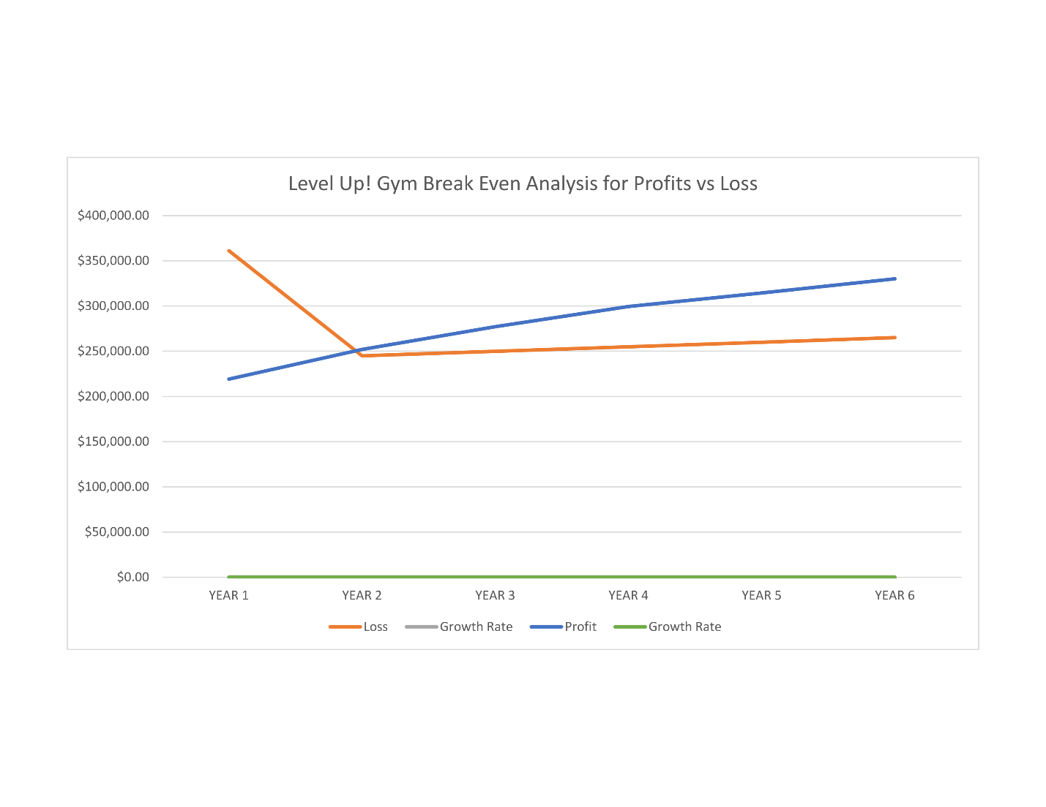

**Company Description**

A cutting edge video game inspired gym that provides a new dimension to fitness. Level Up! Gym provides personalized and innovate game training that keeps you interested and motivated while keeping you easily engaged and working hard to achieve your fitness goals.

Fun and suitable for all ages and skill levels, Level Up! Gym aims to make getting fit and staying fit, fun and addicting, for everyone.

**Vision**

Bringing fitness into the gaming community and providing a new dimension to fitness to appeal to those who have trouble sticking with traditional gym regimes.

**Core Values**

Fun. Fitness. Motivation. Leadership. Health. Well-being

**Mission Statement**

Level Up! Gym plans to promote a healthy lifestyle through entertaining video games, interactive equipment and video game inspired workouts. We make working out an interactive adventure that really keeps you motivated. Providing goal driven standards that develop leadership abilities in each and every person so that they too can spread those skills and we can achieve a higher quality of health for everyone.

**Management Plan**

**Management Team**

CHELSEA FERGUSON

Born and raised on Prince Edward Island, Chelsea Ferguson always had a great appreciation for the natural beauty and the abundance of natural resources found on this little island among the waves. A graduate of the Video Game Art and Animation program and the Computer Information Systems program at Holland College, Chelsea has a solid background in video game design and art, programming and software development. Through her love of video games and fitness, she strived to find a more viable option that provides dynamic fitness to many different kinds of people.

Possessing a creative mind and a technical brain, Chelsea brings a unique blend of abstract and technical thinking to the business. Chelsea strives to make Level Up! Gym, a welcoming place for future members, and future game designers and programmers. With the ever changing world of technology, Chelsea noticed a trend of more people sitting for longer periods of time to use their many devices. Less people, both young and old, are getting physical exercise which is very important not only for one’s physical health, but for their mind as well.

As Chief Executive Officer, Chelsea is the creative mind behind Level Up! Gym. Always inventing new and interesting ways to promote a healthy lifestyle, Chelsea strives to keep Level Up! Gym innovative, inspiring, and fun for everyone. She enjoys working with others and bringing out the best in each person. Being CEO allows her to work with all aspects of the business and truly allows her understand the inner workings thus allowing her to be a better leader. Her duties also include lead designer, graphic artist, assistant programmer, and working alongside the Chief Operational Officer, Christopher, to keep Level Up! Gym organized and running smoothly and efficiently.

CHRISTOPHER SIGOUIN

Christopher Sigouin is a native of Prince Edward Island and a graduate of the Computer Information System (CIS) program at Holland College. His work history includes various types of customer service related positions such as technical service support and accounts receivable representative. A great deal of his business knowledge base comes from volunteer web development / design experience as well as business related course content during his education. He has a passion for programming, interests in video games and a dry sense of humour at times that requires an explanation afterwards. Described as a confident and highly organized individual, he strives for gold in all endeavours.

Christopher brings a wealth of customer service related experience to Level Up! Gym. Accompanied with great organizational skills and a sharp eye for detail, business processes can run smoothly and efficiently. He possesses strong technical backgrounds in software development and various IT related subjects. With volunteer web development experience under his belt, he can state firsthand how a client’s needs can be addressed and fulfilled. Client needs are ever changing in today's fast paced market, so to face those requirements Christopher uses his keen and open minded intellect to reach satisfactory results.

As Chief Operating Officer (COO) of Level Up! Gym, Christopher is considered as an organizer or inside / operations manager who is responsible for making sure that goals and/or projects are completed by their deadlines. He is to ensure that all operations run smoothly and economically while paying attention to all details necessary. Main duties would include working with managers on any issues that arise, resolving escalated matters accordingly and general day to day operational duties. Once the business moves more into software development production to further its services, Christopher will assist as one of the lead programmers and oversee development projects with the assistance of Mike, Chief Financial Officer.

MICHAEL GERGELY

Mike has always been interested in mathematics and the main reason why is the problem solving aspect. This led him to give programming a try and found it quite enjoying. He is a firm believer in having a balanced life between mental and physical well-being and he tries to accomplish this through regular exercise, eating well and learning as much as he can about physical health. Mike really enjoys working at Level Up! Gym because it allows him to work with numbers and code on a daily basis and also allows him to have a say in the inner workings of the business.

Mike can bring, to the company, a love for doing what his job entails, which is working with numbers, the financial aspect, and programming the many awesome things for the company. I also love exercising and helping others learn how great exercise is. In my past Mike has worked as a volunteer personal trainer so he believes he can have a strong bond with those who are members of Level Up! Gym and help them achieve their goals. Mike has a diploma in Computer Information Systems from Holland College. During his time at Holland College, he learned a very broad selection of computer technologies that are required for developing entire systems and provided the knowledge on safe practices in software development as well as customer satisfaction.

Mike has two primary job responsibilities, being a lead developer alongside Chris, and being the Chief Financial Officer (CFO). As CFO, Mike works with the top level financial aspects of the business, such as designating pay. The majority of his time at Level Up! Gym will involve balancing of finances, daily duties and future software development plans. We will be working on our business website, our apps, and various virtual games that users will play while exercising. These positions require a good foundation in mathematics, and programming.

**Management Team Gaps**

The following headings below outline the areas of expertise that our management team lacks. In order to overcome these gaps in experience, we describe the following methods to fill those particular voids under each heading below. This is to ensure that all areas of the business are addressed with a professional attitude and skill set.

General and Personal Fitness Training

The nature of our companies business is fitness driven; therefore, the most effective methods of training should be implemented for the various age categories that we will cater towards. Our business goals include the hiring of two fitness professionals to oversee each main area and ensure members safety. Research conducted by our team on the subject matter would be taken into consideration while developing the exergaming and profile software.

Daily Sanitization & Hygienic Practices

A fitness facilities reputation depends greatly on how well it is maintained through regular cleaning intervals. To uphold this image and ensure that members feel comfortable in the environment, a full time employee would be hired to manage all aspects of sanitization within the facility.

Terms and Conditions for Memberships

To ensure maximum protection for our business as well as for our clientele, a professional lawyer would be consulted to document and produce a well-structured terms and conditions form that will apply to each and every new member of our facility.

**Personnel Plan**

In the initial stages of our business, we will have a large portion of the duties done by those who are already here. As leadership staff, we will each oversee all operations equally, but still maintain focus on individual roles. Due to the possibly large customer base that may occur once our establishment is fully operational, we will require a few employees to oversee L1 and L2 areas as well as cleaning staff to manage the sanitization of the facility.

Below outline our staffing requirements:

Fitness Professionals

These professionals should be fully qualified to deal with any fitness related questions from our members and be trained in first aid procedures encase injury does occur. We would also look for technical skills with video game consoles, audio / video equipment and general technical prowess, but this will not be fully required as training will be provided.

Cleaning Staff

A professional cleaning staff member will be responsible for the facilities sanitization and general upkeep during business hours. It is vital that this is maintained for the reputation of the business and the wellbeing of our members.

Note:

The following positions have multiple people in the same position, this will be accounted for in the yearly total:

Fitness Professionals: 2

Cleaning Staff: 1

The chart below shows annual dollar amounts payable for each position and based on their rates outlined in the financial section. Each year there is an increase in pay to the position as outlined in the operational section.

|  |  |  |  |
| --- | --- | --- | --- |
| **Position** | Year 1 | Year 2 | Year 3 |
| Fitness Professional ( L1 area ) | $23,520 | $24,360 | $25,200 |
| Fitness Professional ( L2 area ) | $23,520 | $24,360 | $25,200 |
| Cleaning Staff | $20,160 | $21,000 | $21,840 |
| **Total Personal Costs** | $66,660 | $69,720 | $72,240 |

**Organizational Chart**

**Marketing Plan**

**The 4 P’s of Marketing**

**Product**

* Providing an innovative fitness experience by using interactive exergaming equipment
* Customized gym memberships
* Motivating fitness classes
* Level Up! Gym inspiried graphic t-shirts, hoodies and pants
* Protein bars, shakes and sport’s beverages
* Fresh local produce

**Price**

* Level Up! Gym’s pricing scheme is on par with some fitness centers in the area and in other cases is fractionally more expensive. We consider factors such as the type of service we offer, technologies developed and integrated, as well as maintenance required for the overall facility.

**Place**

* Located in a central location in an ever growing and evolving city

**Promotion**

* Level Up! Gym offers many deals for different members. There are membershipdeals for families, seniors, schools, universities/colleges and businesses.
* If a member was to sign up a friend for a full year membership, the member will receive half a year membership for free.
* First time members will receive their first month free when purchasing a yearly membership.
* Members and other people who follow Level Up! Gym on social medias will have the opportunity to win various prizes

**SWOT Analysis**

|  |  |
| --- | --- |
| **Strengths** | **Weaknesses** |
| * Catering towards a niche market * Motivational * Great for individuals and groups * Pop culture based * Members will belong to a community * Real social interaction (vs online) * Fun and entertaining | * Catering towards a niche market * Costly start-up * Location is very important * Software creation * Memberships can be pricey for some members |
| **Opportunities** | **Threats** |
| * Potential growth * Sponsors from video game companies * Merchandising * Solution for individuals that struggle with motivation, anxiety * Builds beneficial healthy habits * E-Sports and events * Integration with schools and Boys & Girls organizations | * Traditional Gym competition * Copy cats * Healthy related issue towards playing excessive games |

**Industry Analysis**

DESCRIPTION:

Our industry analysis is comprised of financial data taken from Industry Canada’s website from two separate industries due to the nature of our facility mixing fitness and video game technologies.

INDUSTRY CANADA - FITNESS AND RECREATIONAL SPORTS CENTRES (NAICS 71394): FINANCIAL PERFORMANCE DATA

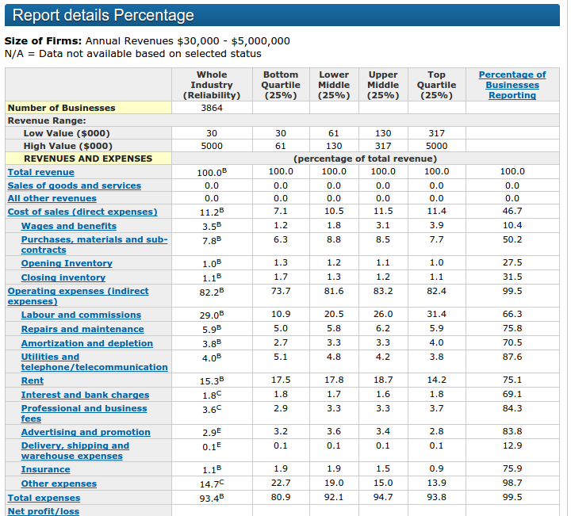

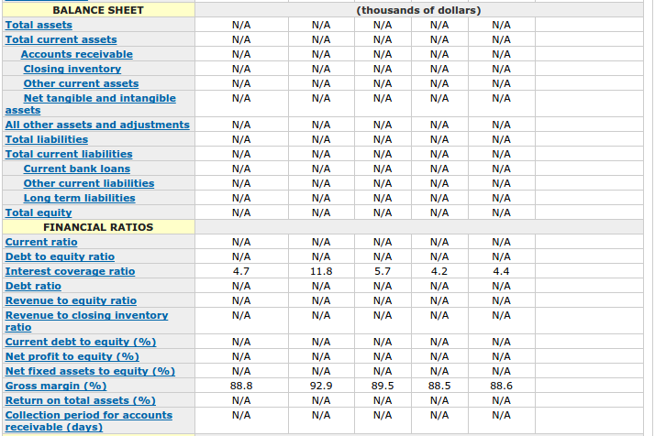

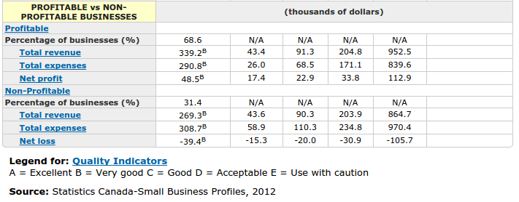

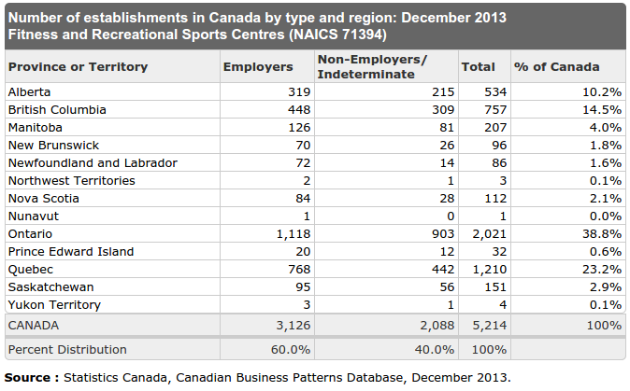

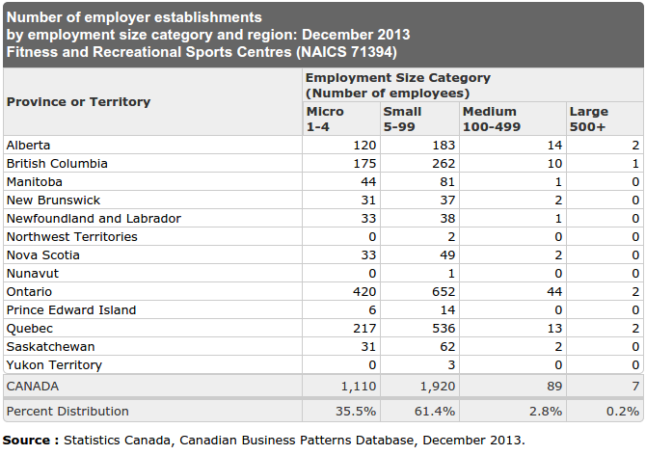

INDUSTRY CANADA - AMUSEMENT ARCADES (NAICS 71312): FINANCIAL PERFORMANCE DATA

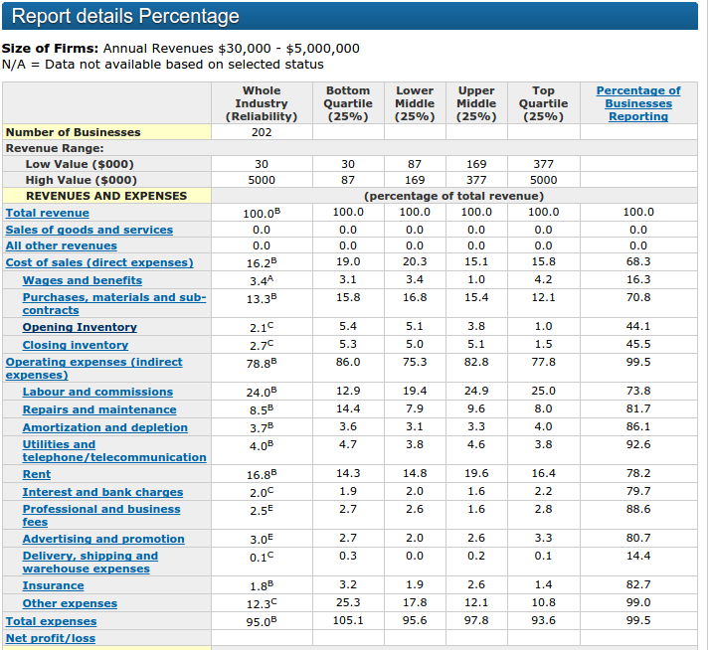

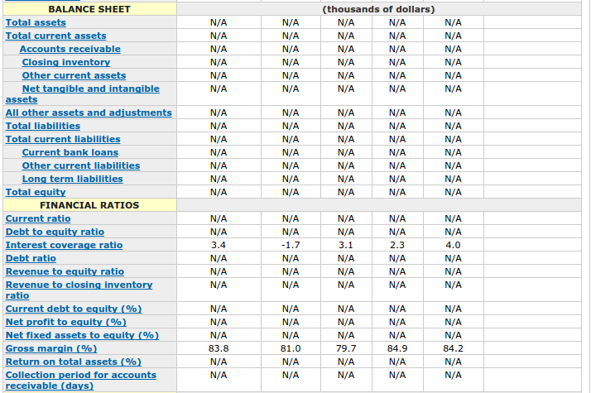

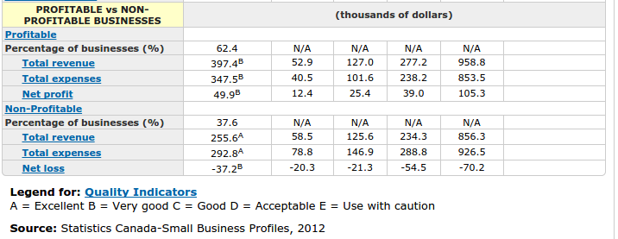

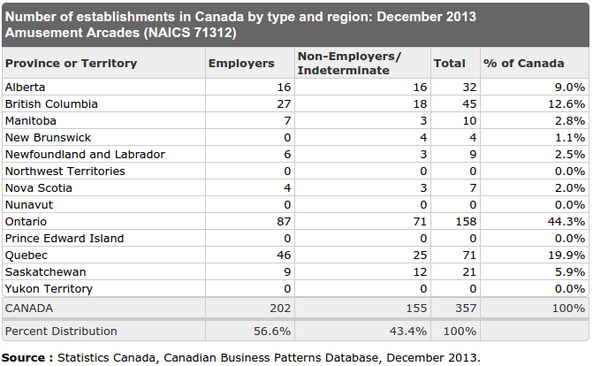

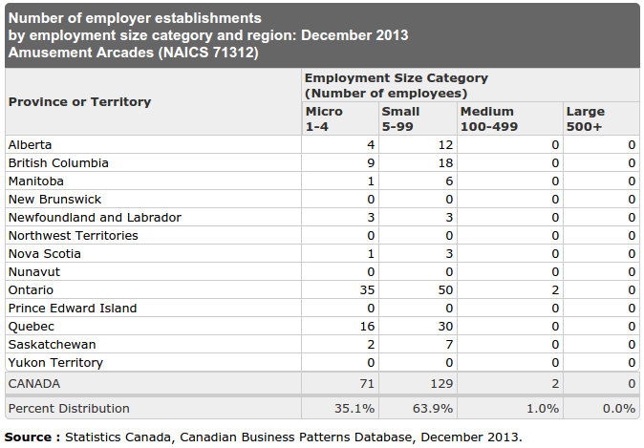

**Market Size**

DESCRIPTION:

Based on the prior reports shown for both industries we define the market size based on the data researched and estimates due to our industry being a unique niche market.

PEI BASED

|  |  |
| --- | --- |
| EXERGAMING FITNESS FACILITIES | 0 |
| FITNESS AND RECREATIONAL SPORTS CENTRES | 32 |
| AMUSEMENT ARCADES | 0 |

Through our research of known fitness facilities located here in Prince Edward Island we have found they contain no known exergaming equipment. Therefore our market size is estimated to be 100%. The YMCA was found to be the largest purchaser of exergaming equipment, but the facility located locally has no such equipment.

**Main Competitors**

DESCRIPTION:

We define three main competitors and include a brief summary about each one. Our summary includes the competitors methods to market their offerings, their size, number of locations, website address and additional information that we believe was relevant

* THE SPA

|  |  |
| --- | --- |
| Size: | 10,000sqft |
| Number of locations: | 1 |
| Website address: | http://spatotalfitness.com/ |
| Methods to market: | Offered as a service |
| Additional information: | * Swimming Pool * Racquetball Courts * Tennis Courts * Indoor track |

* ATLANTIC FITNESS CENTER

|  |  |
| --- | --- |
| Size: | 6000 sqft |
| Number of locations: | 2 |
| Website address: | http://www.atlanticfitness.ca/ |
| Methods to market: | Offered as a service |
| Additional information: | * Yoga classes free to members * Some locations have tanning beds * TRX Suspension Training * Various types of classes |

* CORNWALL APM CENTER

|  |  |
| --- | --- |
| Size: | 1200 square feet fitness room + gymnasium |
| Number of locations: | 1 |
| Website address: | http://www.apmcentre.com/ |
| Method for offerings | Offered as a service |
| Additional information: | * Contains a rink * Has a canteen located within the building * Facility is wheelchair accessible * Various programs offered |

**Market Segments**

DESCRIPTION:

Within this section we review our segments (targets) and analyze each

by breaking them down each segment into these categories:

**Demographic**

Level Up! Gym will market to anyone who enjoys playing video games and would like to get fit and healthy but can’t achieve their goals whether it is from lack of motivation, anxiety from traditional gyms or boring fitness routines.

**Psychographic**

The members of Level Up! Gym will be people who enjoy playing video games and app games, and are fluent in today’s technology. These may be people ranging from late teens to middle aged adults who may be less inclined to be social and find it difficult to find ways to improve their level of fitness.

**Competitive Edge**

DESCRIPTION:

Below is a description of how we will compete with our market competition and rise above the bar that is currently set.

The largest difference between us and regular gyms is our comprehensive experience tracker database which allows our members to view, in real-time, all of the progress they are making. Our core values revolve around motivating members to continue pursuing a fitness infused lifestyle while having fun.

A large portion of people who purchase gym memberships end up quitting or rarely go. We believe that this is because they have no way of viewing their progress, and the physical progress is much too slow to view and believe it is worth it. With our skill tracker database, it not only makes exercise feel like a fun game, it allows you to see all the progress you actually have made.

The main reason why video games are so addicting is the urge to better your character in some way. The user can view their characters skills, experience, items and more from inside the game. This is what we aim for with our skill tracker, and hope to give that same urge to better yourself in the real world.

Our prices fit directly around our competition of regular gyms, but we also offer large discounts for long-term membership purchases. We also offer day passes for visitors to get a feel for how our facility works. Our main goal is to promote healthy living and do not aim for a large profit. This allows us to put much of the gained funds back into the system and improve it for our members.

We offer ways to view your experience, stats and more online through our website. Through the use of our website you can do much more such as, interact with other members, share stories about your fitness goals and even motivate others who are having a hard time.

**Marketing Strategy and Positioning**

DESCRIPTION:

With each of our market segments, we describe below our positioning to market towards them.

**Pricing Strategy**

Our pricing strategy is competition-based pricing. We chose this method because gym environments typically have around the same price, depending on their size and amount of equipment. Our equipment costs are relatively high, and other costs such as electricity are high because of the equipment. The current prices allow us to pay these off and are similar to the larger gyms available in the area.

**Promotion and Advertising Strategy**

Word of Mouth:

Word of mouth will be our primary means of promotion and advertising. The reason this is so important is because our facility caters to a niche group and many in this group want to better themselves through exercise but simply do not have the motivation to do so.

People, for the most part, associate themselves with like-minded people. We believe once our members begin viewing how good this system is they will communicate with their friends.

Our facility is also only a local business for the time being and makes it much less cost-effective to do any large advertising outside of the immediate region.

Social Media:

We will run groups on social media websites such as, Twitter, and Facebook. Through these we will communicate any sales, events and more to our members and others who are thinking of joining.

Being a free means of advertising and how widely it is used we think this is an excellent way to draw in new members. Our targeted members are generally very tech oriented and use social media websites often for various means.

Forums:

Our website will have discussion forums where users can share their fitness stories, talk to other members and motivate others to join or continue through to their goals.

We will have a special area of the forum where users can input their goals and track the date of their desired finish. We will push these posts to the top so that other users can view and discuss with that user how their goals went, if they succeeded and so forth. It is much harder to not finish a goal when you tell others that you have that goal, because you don’t want to disappoint them or yourself.

We will allow anyone to create an account for our website and thus use our forums, so anyone unsure about joining can talk to others and hopefully decide to give it a shot.

**Marketing Programs:**

Word of Mouth:

Budget - $0

Manager - N/A

Time-Table - Duration of business

Goals:

* Members will discuss the idea of fitness and healthy living with their friends
* They will also discuss how it can be fun!
* Bring in their friends for a trial with our day passes and acquire new members
* Bring in 10 members per month

Social Media:

Budget - $0

Manager - Gaylene Nicholson

Time-Table - Duration of business

Goals:

* Share our goals, events and promotions with our members and prospective members
* Have an active face in the fitness community
* Bring in 6 members per month

Forums:

Budget - Included with website hosting costs

Manager - Michael Gergely

Time-Table - Duration of business

Goals:

* Have an active area to talk with other members, share goals and more
* Area for prospective members to talk with staff or other members
* Bring in 5 members per month

**Strategy Pyramids**

DESCRIPTION:

Our strategic goals are broken down into pyramid views so that we can see the steps necessary to achieve our end result. We limit the number of goals we chose so that focus remains strong on each strategy.

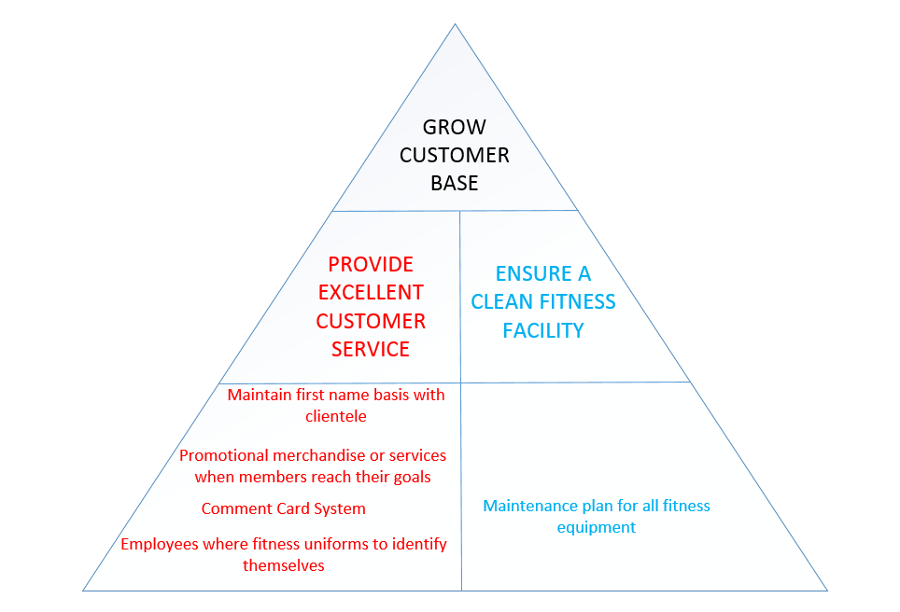

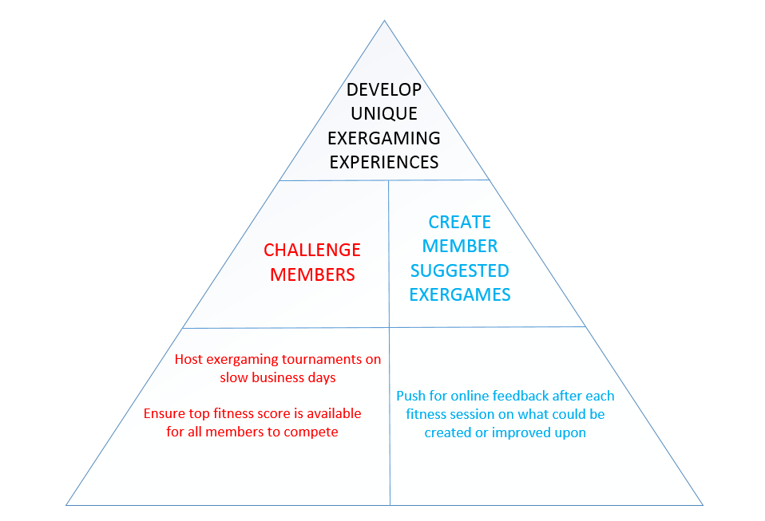

**Website View**

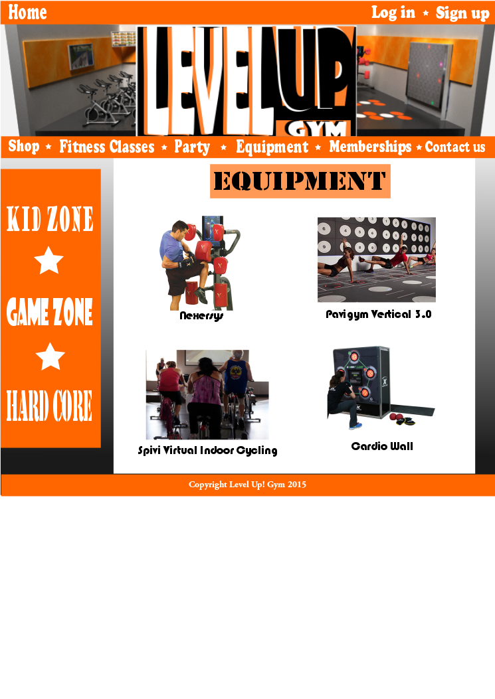

**Legal**

DESCRIPTION:

Here we describe our legal issues such as fitness insurance, software patents and copyright regulations.

FITNESS / HEALTH CLUB INSURANCE

In order for our facility to be fully insured and cover any liabilities that may incur, we would be required to hold a specific fitness facility insurance policy that would protect not only the business, equipment and facility, but its members as well.

Sports & Fitness Insurance Canada

http://www.sportsfitnesscanada.com/wp/wp-content/uploads/2012/07/EGuide-Health-Clubs.pdf

Commercial General Liability (CGL):

Example Scenario:

Member trips over machine and brakes elbow

Professional Liability (E&O):

Example Scenario:

Member was injured by equipment due to lack of maintenance.

Property:

Example Scenario:

Sump pump malfunctions and causes water damage throughout the gym

Crime:

Example Scenario:

Employee is found pocketing fees when signing up members

EXERGAMING & PROFILE SYSTEM SOFTWARE

We are considered an independent software development team creating exergaming software designed to run on the Xbox One and Wii-U gaming consoles.

XBOX SOFTWARE DEVELOPMENT

URL: http://www.xbox.com/en-CA/Developers/id

* + Developer application form required
  + Access to two development kits at no cost
  + Access to all required technical documentation
  + No fees to update any game submitted through the program.
  + Games released through the program also have access to all Xbox One and Xbox Live components, including Kinect, Achievements and Xbox SmartGlass
  + Access to the Unity engine as well as an optional subscription to Unreal Engine 4.
  + Certify with no fees and get access to go-to-market playbook.

WII-U SOFTWARE DEVELOPMENT

URL: https://wiiu-developers.nintendo.com/

* + Developer Application form required to become a Wii U developer.
  + Free development tools ( Unity paid license through Nintendo or NWF )
  + Game Development
  + On-going support
  + Free of charge to participate in the program and to submit games to Nintendo for technical certification
  + Cost involved for Wii U development hardware

GYM PROFILE SOFTWARE

As a software development team designing software to be used in a commercial environment we would be required to register our creation with the Canadian Intellectual Property Office (CIPO). Our business name and product has the following currently registered:

TRADE NAME & TRADEMARK:

Level Up! Gym ( 15 year registration timeline )

COPYRIGHT:

Gym Profile Software ( Lifetime registration )

PATENT:

Gym Profile Software ( 20 year registration timeline )

**Milestones**

DESCRIPTION:

We list and define each of our milestones here. This is to ensure that we keep our business on track and that we can measure the successfulness of our business

|  |  |
| --- | --- |
| **MILESTONE** | **TARGET DATE** |
| Reach 50 customers membership mark | 1 month after business is opened |
| Reach 500 customer membership mark | 2 years after business is opened |
| Recognition as most innovative fitness facility | 5 years after business is opened |
| Purchase additional large scale exergaming fitness units  ( similar to the Eye Play Interactive Floor ) | 6 years after business is opened |
| Establish health food venue within the facility | 6 years after business is opened |
|  |  |

**Exit Strategy**

DESCRIPTION:

Below we outline our business exit strategy in the event that our business fails to

produce an acceptable source of income or we have decided to move into a different market altogether

TRIGGERS

* + Unable to produce an acceptable income in order to support management team members.
  + Unanimous decision in favor of terminating the business

SELLING THE BUSINESS AS A WHOLE

If this choice is a viable one we would be willing to sell the business outright to a potential buyer.

The business would be sold as a whole with all inventory and assets outlined in the sale agreement including the following items:

* Trademark of Level Up! Gym
* Patent for profile software system
* Licenses for exergaming software
* Goodwill

|  |  |
| --- | --- |
| **CURRENT ASSETS** | **WORTH** |
| T-Shirt Merchandise | $15 per unit |
| Pepsi Products | Sold back to Pepsi |
| Mana Potion Products ( can vary depending on stock ) | $3 per unit |

|  |  |
| --- | --- |
| **FIXED ASSETS** | **WORTH** |
| Fitness Facility | Amount of paid-in equity |
| Polk Audio Bookshelf Speaker (R150) – Pair | $1,200.00 |
| Xbox Console Systems + Kinect | $2,000.00 |
| Wii-U Console Systems | $800.00 |
| NEC NP-VE281X Projectors | $6,000.00 |
| NEC NP-VE281X Projector Lamp Replacements | $1,000.00 |
| Eye Play Interactive Floor | $10,000.00 |
| Treadmill Fitness Machinery | $4000.00 |
| Elliptical Fitness Machinery | $4000.00 |
| Stationary Bicycles | $4000.00 |
| Samsung Gear VR | $6,000.00 |
| Mats, Dumbbells, Hula-hoops, Rubber Flooring, Lockers, Gym style benches | $2000.00 |
| Small Sofa's / Loveseats | $5,000.00 |
| Large Desk for Front Desk Area | $100.00 |
| Insignia - 200W 2.0-Ch. Stereo Receiver – Black | $800.00 |

|  |  |
| --- | --- |
| **INTANGILE ASSETS** | **WORTH** |
| Trademark: Level Up! Gym | $10,000 |
| Patents: Exergaming software | $100,000 |
| Patents: Profile Software System | $100,000 |

|  |  |
| --- | --- |
| **GOODWILL** | **$50,000** |

|  |  |
| --- | --- |
| **TOTAL WORTH FOR SELLING** | **$306,000 + Paid-in equity + Inventory** |

**Operational Plan**

**Stage of Development**

**SUBSECTION 1: Current operational development status**

DESCRIPTION:

This subsection describes what we have currently completed to produce an effective and thriving business in our marketplace. These items are geared towards operational aspects and are outlined below:

* Effective location for establishment chosen
* Floor plan design implemented
* Established agreements and negotiations with suppliers
* Equipment chosen to fulfill business needs:

Exergaming software fully developed and tested using the following technologies

Samsung Galaxy Note 4 using Android (used with Samsung Gear VR)

Xbox One using Kinect

Wii-U Nintendo Web Framework

* Profiling software fully developed and tested

**SUBSECTION 2: Unfulfilled development requirements**

DESCRIPTION:

This subsection describes what we have not yet fully implemented and/or completed. This includes items that we cannot consider until initial plans are set into motion. These are required to further our business plan to completion.

* Modifications on fitness equipment to work in conjunction with the profile designed system
* Eye Play Interactive Floor
* Optimal lightning for projector systems

**Risks in development requirements**

DESCRIPTION:

Below we outline the risks that accompany the unfulfilled development requirements. Also included are the steps necessary to fulfill each requirement in the event that the risk does in fact occur and become an issue.

|  |  |
| --- | --- |
| Risk | Modifications on fitness equipment fail to function as intended. The profile system will be prototyped on the same type of equipment purchased so risk is minimal, but still exists. |
| Solution(s) | Revisit test models and troubleshoot as necessary. Speak with supplier and manufacturer to resolve technical issues. |

|  |  |
| --- | --- |
| Risk | The Eye Play Interactive Floor does not work as we had intended. For example, system is not responsive enough to be considered “fun “and usable. |
| Solution(s) | Speak with supplier regarding equipment for any troubleshooting steps. If nothing can be solved then equipment will be returned. Alternatives solutions for replacement of the equipment are as follows:   * Additional console units purchased and implemented * T-Wall 32 Fixed System |

|  |  |
| --- | --- |
| Risk | Lighting in the building affects projector display for consoles and/or main fitness areas. |
| Solution(s) | Work with placement of the projector to ensure best picture possible. |

**SUBSECTION 3:** **Industry Association Memberships**

DESCRIPTION:

Listed below are the following industry organizations that we currently have a membership status with and the organizations that we plan to obtain a membership with in the future. Also, we list any rules or regulations that we must abide by in regards to our particular industry.

|  |  |
| --- | --- |
| CURRENT MEMBERSHIP STATUS | |
| Charlottetown Chamber of Commerce  <http://www.charlottetownchamber.com/> | The Greater Charlottetown Area Chamber of Commerce is a non-profit organization made up of business and professional people sharing a common goal - the economic development of the capital region. |
| PEI Business Women's Association  <http://peibwa.org/> | PEIBWA is a non-profit organization that represents business women across the province. Our mandate is to empower and inspire women to succeed in their business endeavours by providing support, education and opportunities to connect with other women in business. |
| X Ten – The Exergaming Network  <http://exergamenetwork.blogspot.ca/p/nominations.html>  <http://exergaming.pbworks.com/> | TEN is a not-for-profit and non-affiliated Games for Health advocacy promoting an active and healthy lifestyle by combining video games technologies and exercise, known as Exergaming. TEN is an international collaboration of dedicated health and fitness practitioners, exergaming developers, researchers and clinicians, health and fitness entrepreneurs and passionate individuals devoted to highlighting the best solutions offered by exergaming. |

|  |  |
| --- | --- |
| PROCESS OF ACQUIRING MEMBERSHIP STATUS | |
| Fitness Industry Council of Canada  <http://ficdn.ca/> | Fitness Industry Council of Canada (FIC) represents the voice of fitness facility operators across Canada. Representing over 5,000 facilities with over 4 million members nationwide, FIC pursues a legislative agenda in the hope of bettering the fitness industry for both consumers and operators. |
| IDEA Health and Fitness Association  <http://www.ideafit.com/> | Over 250,000 fitness professionals and 10,000 clubs from over 80 countries look to IDEA to make their passion their business. We are the world's leading organization for fitness and wellness professionals and work to deliver unparalleled success tools to fitness professionals and clubs. |
| IHRSA  <http://www.ihrsa.org/> | IHRSA, the 'International Health, Racquet & Sports club Association' is the trade association serving the global health club and fitness industry. The mission of IHRSA is to grow, protect and promote the health and fitness industry, and to provide its members with benefits that will help them be more successful. |

**SUBSECTION 4:** **Suppliers**

DESCRIPTION:

Information regarding our dealers and suppliers of various equipment, merchandise and services that are required to provide our daily services for client members.

|  |  |  |
| --- | --- | --- |
| **BEST BUY CANADA & US** | | |
| **PRODUCT** | **PRICE** | **TERMS & CONDITIONS** |
| Samsung Gear VR Headset | $200 per unit | Geek Squad Protection Plan  2 years  Warranty Terms  Parts - 1 Year(s) |
| Samsung Galaxy Note 4 | $800 per unit | Warranty Terms  Parts - 1 Year(s)  Labour - 1 Year(s) |
| Xbox One with Kinect | $500 per unit | Geek Squad Protection Plan  2 years  Warranty Terms  Parts - 1 Year(s) |
| NEC Pocket Projector (NP-VE281X) | $500 per unit | Warranty Terms  Parts - 1 Year(s) |
| Wii-U Systems | $100 per unit | Geek Squad Protection Plan  2 years  Warranty Terms  Parts - 1 Year(s)  Labour - 1 Year(s) |
| Insignia™ - 200W 2.0-Ch. Stereo Receiver – Black | $100 per unit | Geek Squad Protection Plan  2 years  Warranty Terms  Parts - 1 Year(s) |
| Polk Audio Bookshelf Speaker (R150) - Pair | $100 per unit | Geek Squad Protection Plan  2 years  Warranty Terms  Parts - 1 Year(s)  Labour - 1 Year(s) |

|  |  |  |
| --- | --- | --- |
| **MOTION FITNESS** | | |
| **PRODUCT** | **PRICE** | **TERMS & CONDITIONS** |
| iDance 8 Player Setup | $15,795 | Warranty: Hardware 1 year.  Software License: Lifetime.  Technical Support: 90 Days |
| Eye Play Interactive Floor | $9,995  + $1000 Installation and Training US & Canada | Warranty: Hardware 1 year.  Software License: Lifetime.  Technical Support: 90 Days |
|  |  |  |

|  |  |  |
| --- | --- | --- |
| **SPARTAN FITNESS** | | |
| **PRODUCT** | **PRICE** | **TERMS & CONDITIONS** |
| Elliptical | $2000 | 5 year labour warranty plan  “ Lemon – Aid “ Policy  Transferable Warranty |
| Stationary Bikes | $2000 | 5 year labour warranty plan  “ Lemon – Aid “ Policy  Transferable Warranty |
| Treadmill | $2000 | 5 year labour warranty plan  “ Lemon – aid “ Policy  Transferable Warranty |
| Mats, Dumbbells, Hula-hoops, Rubber Flooring, Lockers, Gym style benches | $2000 | 5 year labour warranty plan |
|  |  |  |
| **PROJECTOR LAMP SOURCE** | | |
| **PRODUCT** | **PRICE** | **TERMS & CONDITIONS** |
| NEC NP-VE281X Projector Lamp Replacement | $210 per unit | FREE 180 Day Extended Projector Lamp Warranty |
|  |  |  |

|  |  |  |
| --- | --- | --- |
| **STAPLES** | | |
| **PRODUCT** | **PRICE** | **TERMS & CONDITIONS** |
| Office Supplies ( Paper, Pens, Notepads, Whiteout ) | $400 | None applicable |

|  |  |  |
| --- | --- | --- |
| **COWS ICE CREAM ( T-Shirt Supplier )** | | |
| **PRODUCT** | **PRICE** | **TERMS & CONDITIONS** |
| Various designer t-shirts using our own graphics | $15 per unit ( > 100 units )  $20 per unit ( < 100 units ) | General quality agreement to reprint shirts if not satisfied |
| Hoodies | $30 per unit ( < 100 units ) |  |
| Sweat Pants | $30 per unit ( < 100 units ) |  |
| Ball Caps | $15 per unit ( < 100 units ) |  |

|  |  |  |
| --- | --- | --- |
| **HARCOS LABS** | | |
| **PRODUCT** | **PRICE** | **TERMS & CONDITIONS** |
| Mana and Health Potion Mix Pack | $120 for 48 units | None applicable |

|  |  |  |
| --- | --- | --- |
| **PEPSI CO.** | | |
| **PRODUCT** | **PRICE** | **TERMS & CONDITIONS** |
| Gatorade Protein Drinks | $2 per unit | None applicable |
| Energy Drinks | $2 per unit | None applicable |
| Pepsi Cooler | $50 monthly rental fee | Repairs to the cooler require Pepsi Co. to complete repairs ( cost included with rental )  Any products that are spoiled or damaged due to the malfunction of the cooler are replaced at no charge. |

|  |  |  |
| --- | --- | --- |
| **BELL ALIANT** | | |
| **PRODUCT** | **PRICE** | **TERMS & CONDITIONS** |
| Business Class FiberOP Internet 250/30 + Web Hosting Service Plan | $300 | FiberOP  Bell Aliant does not guarantee uninterrupted working of its services or equipment. The company shall not be liable to any customer, user or other person for damages resulting from omissions, interruptions, delays, errors or defects in transmission, or failures or defects in Bell Aliant's facilities. However, in any such case, Bell Aliant shall, on request, make a refund of charges proportionate to the length of time the problem existed.  Webhosting   * 30 GB of web space * 2 TB of data transfer / mo. |
|  |  |  |

**SUBSECTION 5:** **Quality Control**

DESCRIPTION:

The environment of a fitness facility should be kept clean and germ free as much as humanly possible. Therefore the reputation and integrity of our business will depend on proper quality control procedures. In this section, we will outline the necessary steps required to ensure that quality.

**Sanitization**

* Devices worn and handled by clients must be cleaned after each use at the minimum
* Cleaning supplies are left in each fitness area to allow customer usage
* All large fitness equipment regularly cleaned
* Areas of fitness must also be sanitized regularly throughout the day
* Locker / Shower rooms must also be cleaned and sanitized at the beginning and end of each shift

**Equipment checks**

* All devices will require testing on a regular basis to ensure their functionality.
* If a device must be serviced regularly (including any technological devices) it will be documented in a servicing timesheet.
* Daily equipment inspections while doing facility rounds to ensure safety and customer satisfaction

**Production Process**

**SUBSECTION 1: Day to Day Operations**

DESCRIPTION:

This section is sub divided into two main sections. The first subsection deals primarily with any rules and regulations applying to the facility, its members and employees.

The next section covers daily operations of our fitness facility along with a timesheet of open hours, rules and regulations for members, and general duties.

**PART 1: General Rules and Regulations**

CUSTOMER MEMERSHIP AGREEMENT:

REFUND POLICY

We do not offer any refunds on any of our memberships offered. If an issue arises regarding a refund, management staff would be called upon to access the situation and resolve as necessary.

USE AT OWN RISK

All facility and system use would be considered “Use at own risk “. L1 area customers (ages 12 and below) must be accompanied by a consenting adult (age 18+) or use of the facilities will be restricted. L2 area is also use at your own risk. Management staff will periodically check areas to ensure safety and fun factor is satisfactory.

WII, XBOX AND VR EQUIPMENT

If devices or not returned or systems are damaged in some way that are deemed un-necessary destruction of property, per agreement that client signs will be liable to pay the full cost of one system that they were using.

MEMBERSHIP VERIFICATION:

Membership cards are used with the facilities electronic access control system. Once a member is registered they will be provided a card that will allow them to do the following within the facility:

* Verification at the front desk when entering the facility
* Logging into the profile system connected to exercise equipment in L2 area

GENERAL GYM CONDUCT

* + - Conduct yourself in a well-mannered fashion.
    - Approach other members in a friendly and respectful way.
    - Allow fellow members to work in between sets.
    - Replace all weights/equipment to their proper place when you are finished using them.
    - Place dumbbells/weight equipment lightly on the floor after each use.
    - Use of mobile devices is permitted in all areas of Level Up! Gym.
    - Request permission from management if you need to take photos or videos. Image capturing is not permitted in the change room area.
    - Please be respectful of the open hours and ensure you have enough time to leave the before the closing time.
    - Wipe down your equipment after use.
    - For your health and safety, wear appropriate exercise clothing and proper athletic footwear. Guidance as to suitable attire may be obtained from the General Manager of the Club.

RULES FOR XBOX AND WII ROOMS:

* + - Treat all console systems and equipment within the room as if they were your own personal property.
    - Rooms will be locked at all times except when in use by clientele.
    - Wii devices and Xbox devices (everything but console, sensors and Kinect systems) are provided to clientele on a per use basis. They are kept behind the desk in the storage room area.

LOCKER AND BATHROOM AREAS:

LOCKERS

There are to be no locks left on any locker after business hours. In the event that there is a lock left, the lock will be removed and the contents emptied. Items from said locker will be held for a period of 5 days in a storage area to allow for reclaiming. Otherwise, the items will be discarded.

BATHROOMS/SHOWERS

Towels, facecloths and other bathroom and shower items are not provided. These must be provided by the clients.

FIRE ESCAPE PLAN

In the event of a fire there are 3 designated exits in the building. One is available in each exercise area (L1 and L2) as well as the entrance to the building. Signage will be placed in the building to indicate emergency exits.

**PART 2: Facility Hours, Duties and Operations**

HOURS OF OPERATION

|  |  |  |  |  |  |  |
| --- | --- | --- | --- | --- | --- | --- |
| **SUN** | **MON** | **TUES** | **WED** | **THUR** | **FRI** | **SAT** |
| CLOSED | OPEN 5:30am | OPEN 5:30am | OPEN 5:30am | OPEN 5:30am | OPEN 5:30am | OPEN  9am |
| CLOSED | 1ST SHIFT  6am – 1pm | 1ST SHIFT  6am – 1pm | 1ST SHIFT  6am – 1pm | 1ST SHIFT  6am – 1pm | 1ST SHIFT  6am – 1pm | 1st SHIFT  9am – 1pm |
| CLOSED | 2nd SHIFT  1pm – 8:30pm | 2nd SHIFT  1pm – 8:30pm | 2nd SHIFT  1pm – 8:30pm | 2nd SHIFT  1pm – 8:30pm | 2nd SHIFT  1pm – 8:30pm | 2nd SHIFT  1pm – 5pm |
| CLOSED | CLOSE  9pm | CLOSE  9pm | CLOSE  9pm | CLOSE  9pm | CLOSE  9pm | CLOSE  5pm |

MAIN DAILY DUTIES

MONDAY – FRIDAY

* 15 open hours per day consisting of 2 x 7.5 hour shifts
* Shifts will consist of two managers, two fitness professionals and one cleaning staff member.
* Each manager takes responsibility for front desk operations and L1 or L2 section. These positions may change during the business day, based on the need of manpower at the time.
* Each fitness professional has a responsibility to oversee either L1 or L2 areas and work with members on a daily basis, ensure safety and promote fun!
* In the event that business operation is slow, on duty managers will inspect L1 and L2 areas to ensure safety and customer satisfaction. Main duties will remain at front desk to welcome in new clients and conduct daily business
* Managers will be equipped with walkie-talkies for communication if an issue arises
* Bathrooms and shower areas will be cleaned three times daily ( morning, noon and at the end of each shift )
* Regular review of equipment sanitization as necessary by cleaning staff.

SATURDAY

* 7 open hours per day consisting of 2 x 3.5 hour shifts
* Business operations for SAT are the same as MON-FRI open hours

**SUBSECTION 2:** **Physical Location**

DESCRIPTION:

This section explains the physical location type, size and location chosen for our business. Also we explain the purpose of why the building is important to our chosen business model.

TYPE OF PREMISES

Vacant Fitness Facility

LOCATION

300 Brackley Point Road, Charlottetown PE C1E 2E6

SIZE

10,000 SQ FT

IMPORTANCE OF FACILITY

The facilities structure and layout is important because it allows us to implement our gym seamlessly with minimal modifications aside from soundproofing for specific areas. The building’s design provides us the layout for our two needed areas named Level 1 (L1) and Level 2 (L2).

L1 - Youth and Teens (Ages 8 – 15)

L2 - Teens and Adult (Ages 16 and up)

Each area would contain equipment appropriate for each age group. Each area will have 4 designated rooms for console based exergaming. Two will be dedicated Xbox rooms and two are dedicated Wii-U rooms.

**SUBSECTION 3: Equipment**

DESCRIPTION:

This section explains the equipment that we have deemed necessary for our business to operate on a daily basis per operational hours. Also explained below is why the equipment is important, quantity and any financing arrangement made for the equipment shown.

|  |  |  |  |
| --- | --- | --- | --- |
| **EQUIPMENT** | **QUANTITY** | **IMPORTANCE** | **FINANCING** |
|  |  |  |  |
| iDance 8 Player System | 1 | Used in L2 area. Allows 8 members to simultaneously play a session. | n/a |
| Samsung Gear VR | 15 | Used in conjunction with fitness machinery (i.e. Treadmills, Elliptical and Stationary Bicycles ) | n/a |
| Xbox Console Systems + Kinect | 4 | Exergaming software developed to be used on Xbox console systems | n/a |
| Wii-U Console Systems | 4 | Exergaming software developed to be used on Xbox console systems | n/a |
| Insignia - 200W 2.0-Ch. Stereo Receiver – Black | 10 | Each console exergaming room and open fitness areas (L1 and L2) require a sound system to provide audio | n/a |
| Polk Audio Bookshelf Speaker (R150) – Pair | 10 | Each console exergaming room and open fitness areas (L1 and L2) require a sound system to provide audio | n/a |
| 5 NEC NP-VE281X Projector | 12 | Each console exergaming room and open fitness areas (L1 and L2) require a video display screen to display exergaming software and profile systems | n/a |
| 5 NEC NP-VE281X Projector Lamp Replacement | 5 | Replacement lamps for projectors as they will be under heavy use during daily operations. Lamps have a limited lifecycle. | n/a |
| Eye Play Interactive Floor | 1 | Main fitness attraction for L1 area (ages 8 – 15). This will encompass at least 50% of that particular area allowing large groups to utilize it. | n/a |
| Treadmill Fitness Machinery | 5 | Main fitness equipment used in L2 area in conjunction with VR equipment and profile system | n/a |
| Elliptical Fitness Machinery | 5 | Main fitness equipment used in L2 area in conjunction with VR equipment and profile system | n/a |
| Stationary Bicycles | 5 | Main fitness equipment used in L2 area in conjunction with VR equipment and profile system | n/a |
| Padded exercising mats | 20 | Used for general use in fitness related activities | n/a |
| Dumbbells | 4 sets | Used for general use in fitness related activities | n/a |
| Rubber Flooring | 1000 sq. ft. | Required to ensure safety | n/a |
| Lockers | 20 | Required for customers to store personal belongings while enjoying facility services | n/a |
| Hula-hoops | 20 | Used for general use in fitness related activities. Mainly a L1 area type of equipment. | n/a |
| Gym style benches | 10 | Benches are situated in each fitness area (L1 and L2) as well as in the locker area and bathrooms. | n/a |

**SUBSECTION 4: Assets**

DESCRIPTION:

Current, fixed and intangible assets are listed below. Descriptions include the name of each asset and the total worth.

|  |  |
| --- | --- |
| **ASSET NAME** | **WORTH** |
| Fitness Facility | $1,250,000.00 ($100 to $125 sqft) |
| T-Shirt Merchandise | $1500.00 |
| Pepsi Products | $200.00 |
| Mana Potion Products | $120.00 |
| Xbox Console Systems + Kinect | $2,000.00 |
| Wii-U Console Systems | $800.00 |
| NEC NP-VE281X Projectors | $6,000.00 |
| NEC NP-VE281X Projector Lamp Replacements | $1,000.00 |
| Eye Play Interactive Floor | $10,000.00 |
| Treadmill Fitness Machinery | $4000.00 |
| Elliptical Fitness Machinery | $4000.00 |
| Stationary Bicycles | $4000.00 |
| Samsung Gear VR | $6,000.00 |
| Mats, Dumbbells, Hula-hoops, Rubber Flooring, Lockers, Gym style benches | $2000.00 |
| Small Sofa's / Loveseats | $5,000.00 |
| Large Desk for Front Desk Area | $100.00 |
| Insignia - 200W 2.0-Ch. Stereo Receiver – Black | $800.00 |
| iDance 8 Player System | $16,000.00 |
| Polk Audio Bookshelf Speaker (R150) – Pair | $1,200.00 |

**SUBSECTION 5: Inventory**

DESCRIPTION:

This section explains how our business will keep track on any inventory during our day to day operations.

METHOD OF TRACKING

Inventory will be tracked by the same system we use as a cash register. This would be a front desk computer system that would log the item as it is purchased.

CLOTHING MERCHANIDSE

To be counted once per month to ensure quantity on hand is correct. Merchandise will be kept behind the front desk for theft prevention reasons and ease of transactions between clients.

Unless demand increases our initial stock quantity will remain as follows:

|  |  |
| --- | --- |
| T-Shirts | 100 |
| Hoodies | 25 |
| Sweat Pants | 25 |
| Ball Caps | 25 |

BEVERAGES (PEPSI)

Beverages kept in cooler from Pepsi will be stocked and managed by a Pepsi representative. This representative will conduct an inventory check on the beverages every two week period.

If stock becomes 10 units or less for either other drinks or gatorade protein drinks then a request will be made to top up our stock to 50 units.

**SUBSECTION 6: Feasibility**

DESCRIPTION:

Product and prototype testing that we have completed with our designated product or service is listed here.

EXERGAMING SOFTWARE

Each exergaming software product that we have designed has been fully tested and integrated into the following types of technology that will be used on a daily basis. Through each development framework provided by these organizations, we can be assured that the software is fully compatible.

* Xbox One Console using Kinect
* Wii-U Console Systems
* Samsung Gear VR

PROFILING SYSTEM SOFTWARE

The system software that manages an individual’s profile has been tested and integrated with specific models of the fitness machinery that is required

* Cybex International 770T Treadmill
* Cybex 525AT Arc (Elliptical)
* Cybex 625C Upright (Stationary Bicycle)

Simulations of the profile system using the specified models have been tested thoroughly over a 5 year period.

VIRTUAL MERCHANDISE

Part of the profile systems functionality is the ability to sell virtual merchandise to a client while he or she exercises. While the profile system was tested these systems were verified using various popular mobile phone models.

* Samsung Galaxy Note 4
* Koodo LG Nexus 5 Smartphone
* Bell Apple iPhone 6

**SUBSECTION 7: Costs**

DESCRIPTION:

We outline all of our product cost estimates below denoting their type and pricing scheme. These would include individual client type costs as well as business client costs.

|  |  |
| --- | --- |
| **MEMBERSHIP FEES** | **PRICING (Taxes Included)** |
| Day Pass | **$9.99** |
| 1 Month | **$69.99** |
| 6 Month |  |
| 1 Year | **$449.99** |
| Family(2 Adults + 2 Youth(under 18))(Yearly) | **$769.99** |
| Senior(Yearly) | **$349.99** |
|  |  |
| **BUSINESS MEMBERSHIPS(YEARLY) / SCHOOLS(UNIVERSITIES/COLLEGES)** | **PRICING (Taxes Included)** |
| Small - Up to 15 | **$1499.99 (or 100 each)** |
| Medium -  Up to 30 | **$2849.99 (or 95 each)** |
| Large – Up to 75 | **$6749.99 (or 90 each)** |
| X-Large – Up to 150 | **$12,749.99 (or 85 each)** |
| For children with a school(school trip) | **$5 per student, $8 per teacher** |

Products and Services

**Products**

**Shop**

Level Up! Gym offers special merchandise for its clients. Available for purchase are fun stylized t-shirts, hoodies, pants and work out gear. Clothing will sport video-game inspired graphic designs and also Level Up! Gym logos.

**Power Bar**

Since we are focused on providing a healthy, fun, engaging environment for our members, Level Up! Gym also provides healthy, nutritious foods to help keep its members on track.

|  |  |
| --- | --- |
|  | http://www.blogilates.com/wp-content/uploads/2013/02/710IZZyz+pL._SL1500_.jpg |
| Vegan Protein Shakes | Whey Powder Protein Shakes |
| http://d29k3cd729ptld.cloudfront.net/wp-content/uploads/2014/04/Vega-Bar-Launch-Header.png | http://www.bluerivertrading.com/images/Builder-Bar-Image-for-web.jpg |
| Vegan and Gluten Free Protein Bars | Protein Bars |
| http://www.wildrootsfoods.com/Products/images/coastal-berry-blend.jpg | http://district.schoolnutritionandfitness.com/kansascityps/files/fresh_fruit_and_vegetable_picture.jpg |
| Trail Mixes | Fresh Local Produce |
|  |  |
| Health and Mana Potion Energy Drinks | Gatorade Protein Shakes |

**SERVICES**

**Level Up! Gym Profile App**

An integral part of the Level Up! Gym experience, this app really connects and follows members along their fitness journey. Each member will have a unique profile that contains their stats (very similar to that of an rpg). These stats will include the measurements of the member, weight, endurance, and strength. The app allows tracks intelligence (trying and learning new routines), charisma (gained by helping other at the gym or volunteering to help out around the gym) and determination (the number of times a member logs in at the gym). As a member works out, they gain experience points with enough points, they will ‘level up’. When a member levels up, there is a chance for a ‘loot drop’, meaning they have a chance to win anything from merchandise from the shop to free month or more of membership to the Level Up! Gym.

This Level Up! Gym app connects to the company website which can act similar to a social networking site. Members can add friends and share their achievements.

This app also connects to the unique exercise equipment provided at Level Up! Gym. Certain machines will contain games that the member can further and level up in by exercising. The app will track the experience in the games as well and these experience points will also contribute to the overall level of the member.

For the more competitive members, members can engage in PvP (player vs player). These battles could entail races on the exercise bikes, marathons on the treadmill and more.

As members reach certain levels, they will come upon a ‘Boss battle’, which would be a challenging routine they must overcome to level up!

**Fitness Classes**

Level Up! Gym offers unique, video-game inspired fitness classes throughout the week.

**Memberships**

Level Up! Gym offers a variety of memberships for everyone from students to business, children to adults.

**Kid’s Zone**

During the day from 9am to 2pm, schools can book the Kid’s Zone for one class to play and have fun while getting exercise. These would be fun field trips for students to play and get fit in a new and interactive environment.

**Game Zone**

Level Up! Gym provides special rooms called Game Zones. In each room there is a large television or projector and a game console like Xbox, or Wii-U in which gym goers can play popular fitness games using the consoles motion sensing technology. One to eight people can play at a time in one room.

**Party Play**

Members have the ability to rent one or more game rooms for a party! These can range from kid’s birthday parties to teens wanted to hang with friends or even adults who just want to have fun with friends.

**Financial Plan**

**Start-up Expenses**

DESCRIPTION:

Expenses for the first month based on what we require to initialize our business plan.

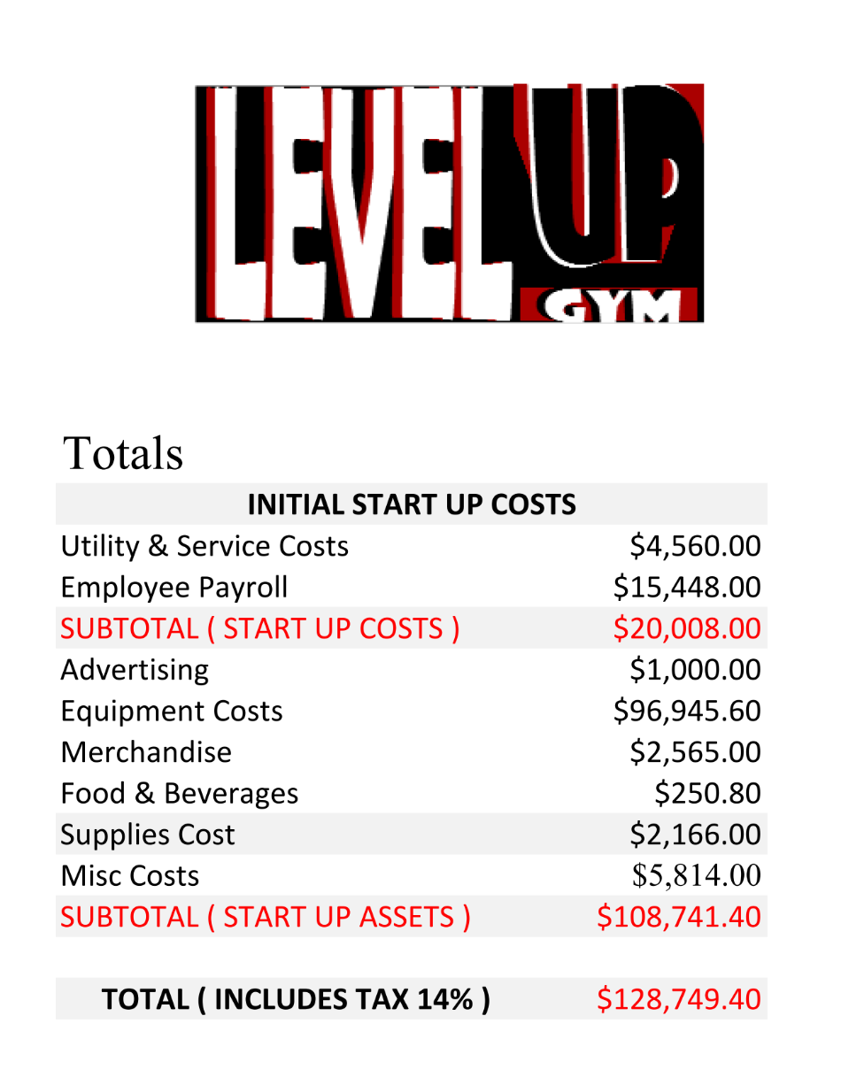

**Start-up Assets**

DESCRIPTION:

Our list of assets, including their quantity, cost and subtotals.

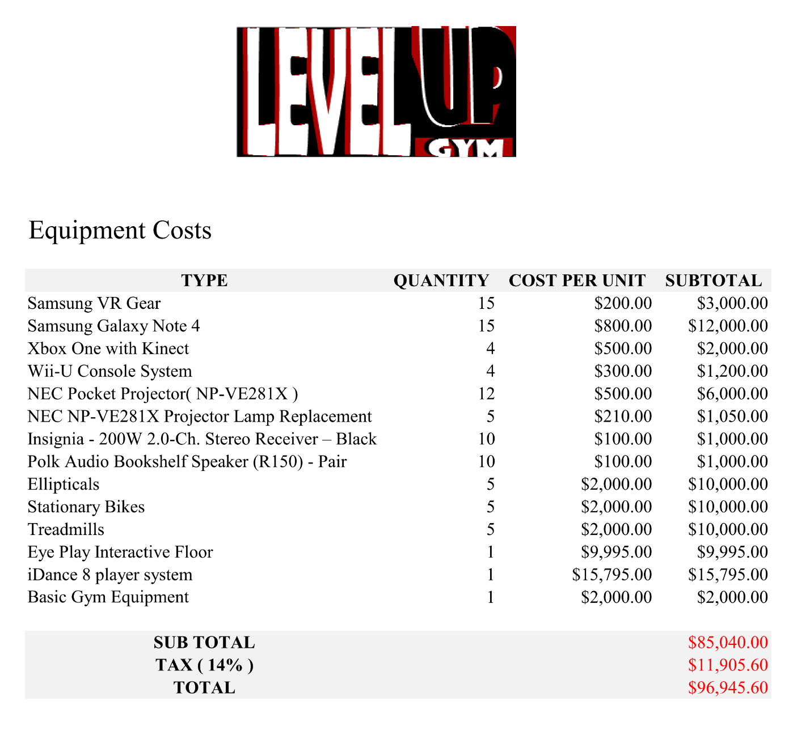

**Source and Use of Funds**

DESCRIPTION:

Level Up! Gym will start with 4 founders. Each will be supplying $15,000 to the start-up costs. This will give us $60,000. Our loan requirement would be an amount equaling $80,000.

Our use of the funds are highlighted in the tables for expenses and assets required. To start off we need a large amount of money to go into buying the equipment necessary to begin the gym. The start-up month will be, by far, the most expensive month we will need because of this. The following months will require some purchases of equipment but not nearly as much as the beginning, meaning our expenses per month will be cut by half or more following the first month.

**Break-even Analysis**

DESCRIPTION:

Currently we are making a predicted $18262.58 per month of profit. After the first month we are estimating monthly expenses to be roughly $20,008.00.

The first five years show no profit earned although the amount decreases substantially based on increased profits from a larger customer base. We see that in our 6th year of operation we will receive a positive profit margin.

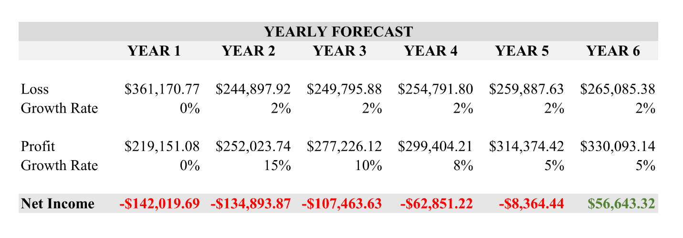

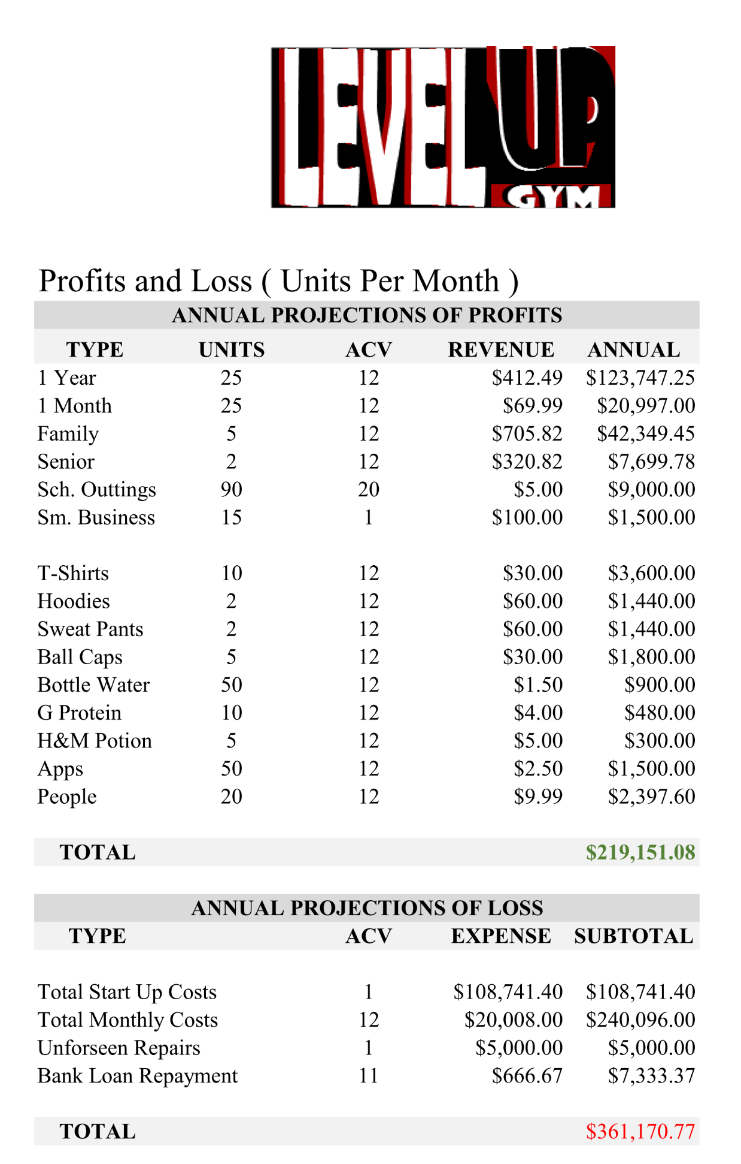

**Profit and Loss**

DESCRIPTION:

This section describes our projected profits and losses over a 5 year span. Moving from Year 2 to Year 5, you can see that we will have an estimated increase in each category by a percentage amount. The projected loss will also increase, but is more stable as service companies increase their pricing yearly. We project that our percentage may drop off after the third year due to less hype regarding the business overall and customer base should be established by that time with a firm amount. Net profit was found by calculating how much was made total – the costs for that year.

ACV – Annual Conversion Vector

Converts all values to an annual state.



**Balance Information**

DESCRIPTION:

Assets:

We will be beginning with $150,000 and will be making an estimated $235,000 that year. This will give us cash assets of $385,000 to work with that year as a total figure.

A large portion of this will be used for long term assets which includes, gym equipment, gaming related equipment, and furniture for the lobby.

Short term assets include office supplies and merchandise which will be sold in-store and online from our website.

Liabilities:

Upon receiving financial aid for our start-up costs, our current plan is to pay at a rate of 5% interest over a 10 year period. Below we list our amortization payment schedule for a loan. This is calculated with the minimal financial amount to allow us to start.

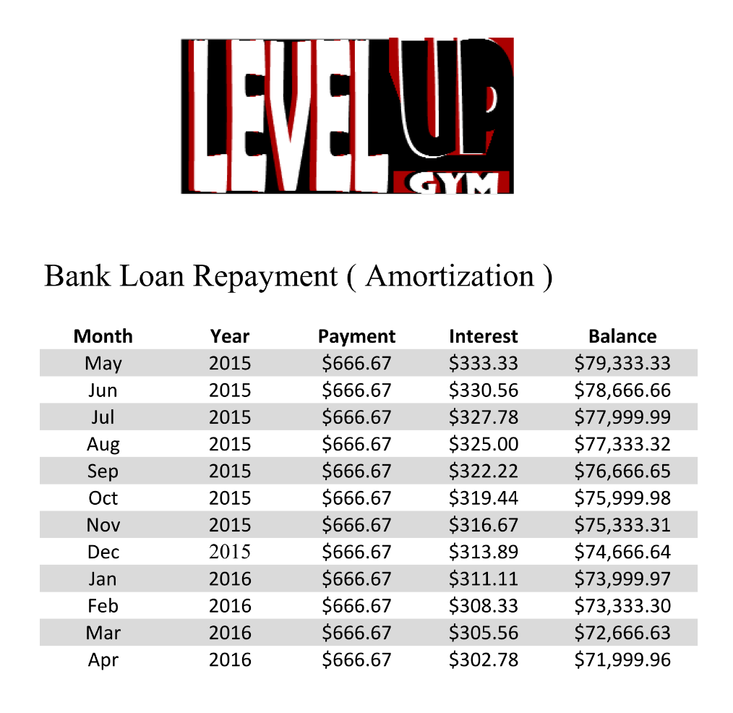

**Budget Sheet**

DESCRIPTION:

Listed below is a graph representation of our monthly budget for a one year span. Costs are estimated to be similar month to month, as there is no large variation in service costs.

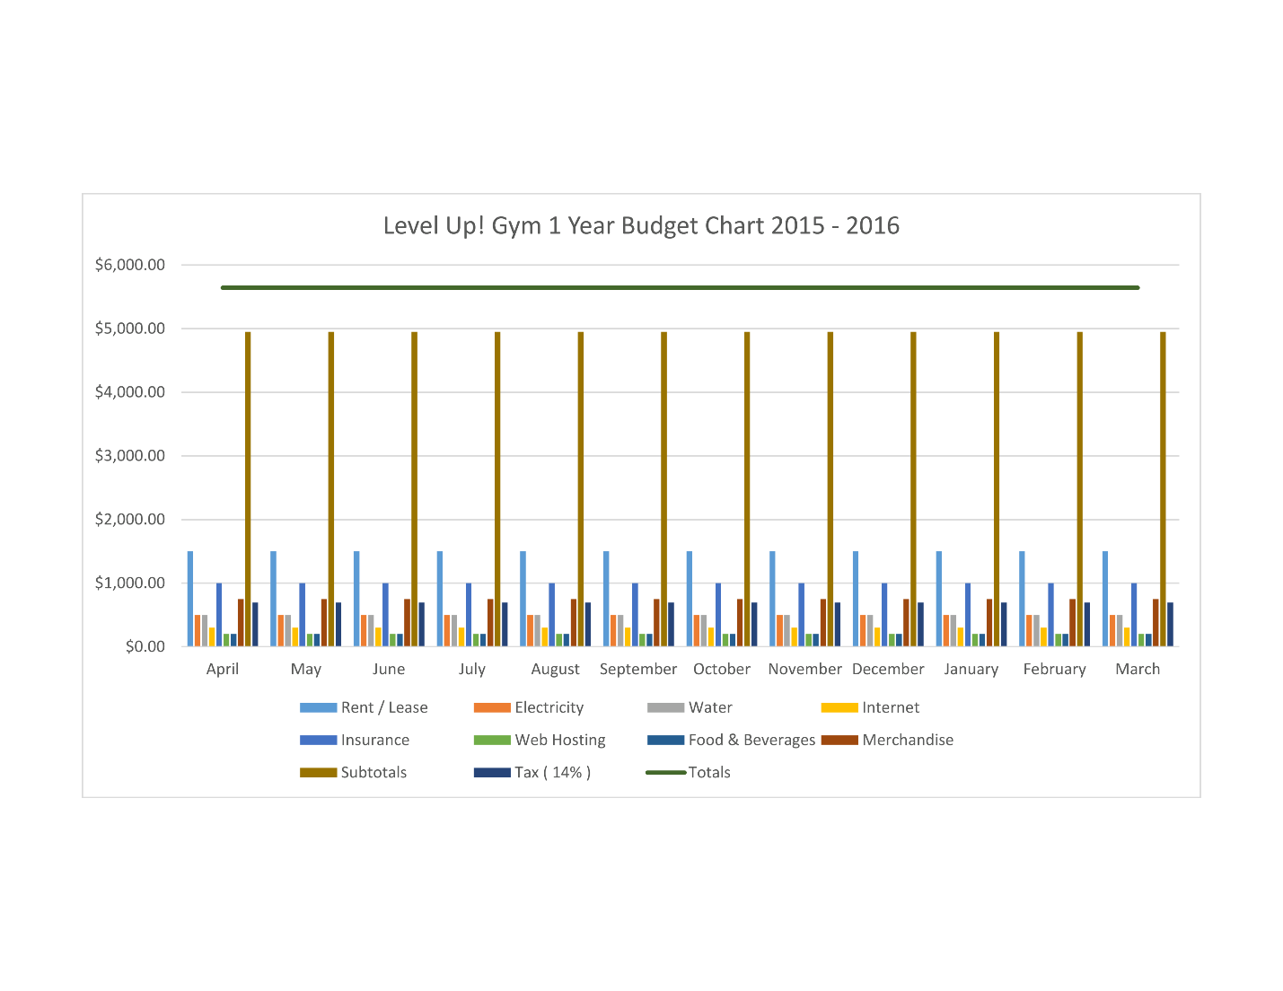

Appendices

**Floor Plan**

**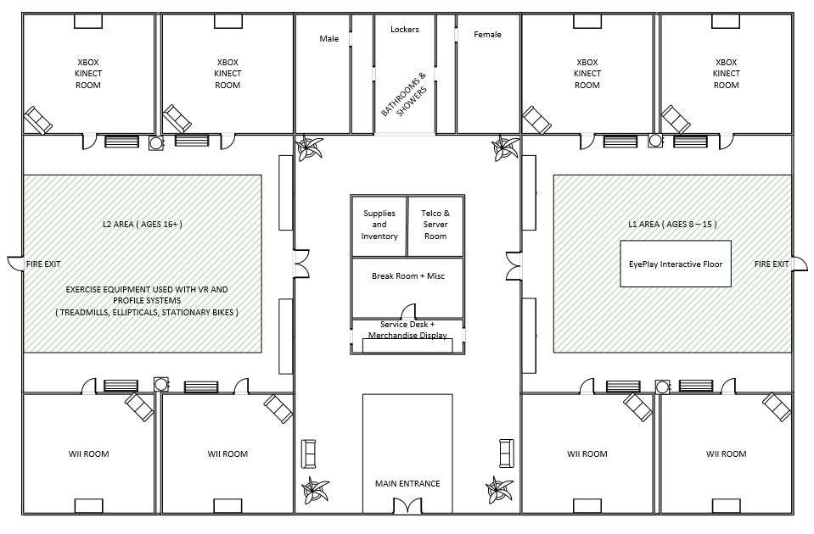**

**Exergaming Equipment Examples**

|  |  |
| --- | --- |
| **C:\Users\Chris\Pictures\Business_Plan_Images\productImages\cybex_international_625c_upright_bike.jpg** | **C:\Users\Chris\Pictures\Business_Plan_Images\productImages\cybex_international_770at_arc_trainer_elliptical.jpg** |
| **Exercise Bike** | **Elliptical** |
| **portfolio-thumb-1** | portfolio-thumb-1 |
| **Fit Interactive 3 Kit** | **Cardio Wall** |

|  |  |
| --- | --- |
| **Consoles** |  |
| **C:\Users\Chris\Pictures\Business_Plan_Images\productImages\xboxone.png** | **C:\Users\Chris\Pictures\Business_Plan_Images\productImages\Wii_U_and_GamePad.jpg** |
| **XBOX One** | **Wii-U** |

|  |  |
| --- | --- |
| **Games** |  |
| http://ecx.images-amazon.com/images/I/61aP4LNnRqL.jpg | http://www.gamesloungestore.com/wp-content/uploads/2013/12/Zumba-fitness-world-party-xbox-one.jpg |
| **Just Dance Games** | **Zumba Fitness Games** |

**Social Action Research Project**

Level Up! Gym is our company. It is a gym targeted at gamers and promoting healthy living among the gaming community. One of the primary reasons individuals are reluctant to begin exercise is because they are self-conscious and afraid to take the first step into the gym. We believe that if gamers feel more “at home” and accepted they will be much more enthusiastic in joining. Another big problem is when you do begin going to the gym, you lose motivation because you aren’t seeing progress as fast as you want. We have built a system, very similar to a role-playing game, where coming to the gym regularly, eating healthy and more will earn you attribute points and levels which you can track online to get a real-time view of all the progress you actually have made. There are many more features about the gym that are gaming-related and make the whole experience much more fun.

Our Social Action project will consist of an event at our gym that will consist of many fun physical activities and competitions that are derived from video-games we all know and love. Afterwards we will have a speaker come in and discuss the importance of healthy living to really drill home to all our attendees that you can live a fun life of gaming while remaining healthy, it just takes some effort but the results are more than worth it. Throughout the event there will be prizes given out, healthy food to eat and more. All who are already members of the gym and any new recruits will be given experience and attributes for attending the event as well, like a real event from a video-game.

From this event everyone in the company and our members will benefit. Through doing this we will be showing the community that fitness is necessary but it can also be fun and something you actually look forward to doing. Our company benefits because of all the publicity and new members joining.

The primary reason we will be doing this project revolves around these ideas and from doing so we will better the company in the views of all. There is always a stigma around gamers and the gaming community that those who participate are automatically anti-social, un-healthy and many more negative views. We are aiming to reduce and eliminate this by having the gamers themselves disprove it. When they see real results and are enjoying themselves they will continue to improve and by doing so prove to all that you can live a healthy life while enjoying immersing themselves in technology. More than ever this is a problem in the world because of how enjoyable it has become to simply stay at home on your computer or television and it needs to be addressed. The public will view this is a big step in the right direction.

We will be having this event at the beginning of summer. We believe this is the best time because many younger people have time off and during the summer is generally when people are most self-conscious and want to make that big change in their lives. Our budget will be roughly $2500. This will cover all prizes and food given away, the guest speaker and any other expenses like advertising. We believe that this will be a worthy investment because we think we will gain many new members in our community from it.

The plan for this happening is to begin advertising a month in advance and target locations where the gaming community thrives. We will be advertising on the game streaming website Twitch.tv, locally at game shops and other various social media platforms.

**Key Personnel-Resumes**

**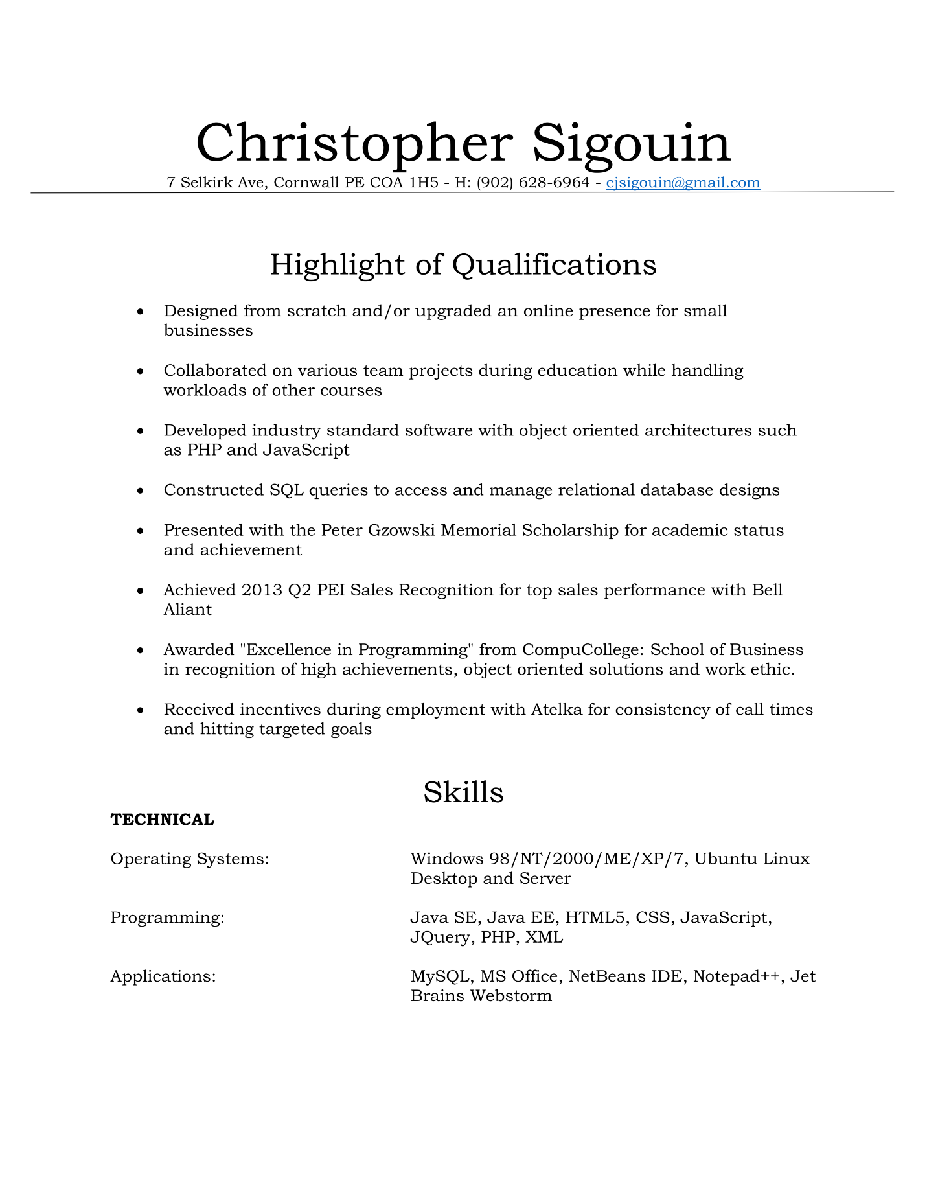**

**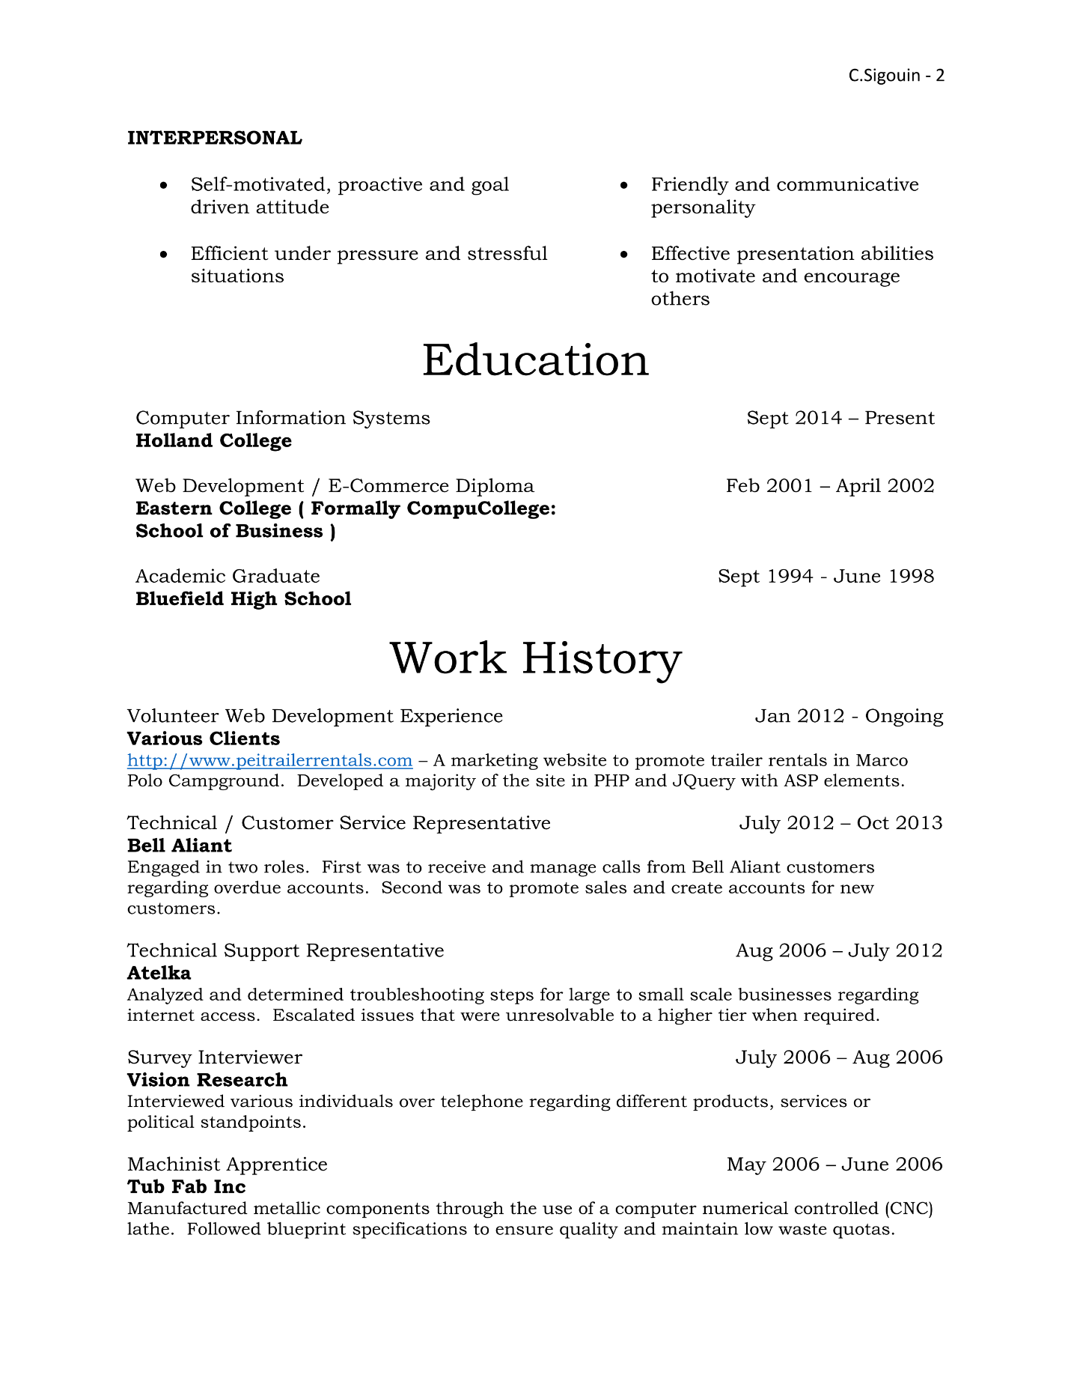**

****

**Chelsea Ferguson**

75 Sandy Point Road, Hampton, PE C0A 1J0

**Cell Phone:** 902-213-3543

**Email:** chelseaferguson.art@gmail.com

**EDUCATION**

|  |  |
| --- | --- |
| **Computer Information Systems (First year student)**   * Holland College, Charlottetown, PE * Two-year program | **September 2014**  **Present** |
| **Video Game Art and Animation Diploma**   * Holland College, Charlottetown, PE * Two-year program | **September 2012**  **May 2014** |
| **Bluefield Senior High School**   * Hampshire, PE * Academic Diploma | **June 2010** |

**SKILL-SETS**

|  |  |
| --- | --- |
| * Adobe Photoshop | * HTML, CSS |
| * Adobe Flash | * Microsoft Word |
| * Autodesk Maya | * Customer Service |
| * ArtRage | * Organization |
| * ZBrush |  |

**EXPERIENCE**

|  |  |
| --- | --- |
| **Artist in Residence**  **Summer Studio, Summerside, PE**   * Created art to display and sell to the public * Worked alongside local artists and artisans * Conversed with the public and aided tourists in finding information * Managed a studio under no supervision * Decorated and planned layout of the studio | **June 2014 to August 2014**  **(Seasonal)** |
| **Baker**  **Beachcombers on the Wharf, Victoria, PE**   * Prepared baked good * Baked cookies, pies, cakes, tarts, etc * Maintained kitchen cleanliness | **June 2013 to July 2013**  **(Part-Time)** |
| **Hostess Server/Cashier**  **Tim Horton’s, Cornwall, PE**   * Maintained clean dining room * Provided excellent customer service * Assembled food and drinks * Worked on cash and on drive-thru window * Maintained bathroom cleanliness | **July 2011 to November 2012**  **(Part-Time)** |
| **Sales Associate**  **Mark’s Work Wearhouse, Summerside, PE**   * Prepared merchandise in shipping and receiving * Stocked the floor * Maintained store cleanliness – dusting, vacuuming, tidying * Assisted customers with their purchases * Worked as a team player * Provided excellent customer service | **November 2011 to March 2011**  **(Casual)** |

**INTERESTS**

|  |  |
| --- | --- |
| * Traditional Art | * Programming |
| * Digital Art | * Web Development |
| * 2D/3D Animation | * Web Design |
| * 3D Modelling | * Software Development |
| * Video Games |  |

**REFERENCES**

|  |
| --- |
| **Don Bowers**   * Computer Information Systems, Learning Manager, Holland College, PE * Phone: 1(902)566-9338 * Email: [dfbowers@hollandcollege.com](mailto:dfbowers@hollandcollege.com)   **Tiffany Baxter**   * Video Game Art and Animation, Learning Manager, Holland College, PE * Phone: 1(902)566-9664 * Email: tdbaxter@hollandcollege.com |
| **Trevor Carroll**   * Store Manager, Mark’s Work Wearhouse, Charlottetown, PE * Phone: 1(902)566-5668 * Email: terri-trevor@bellaliant.net |
|  |